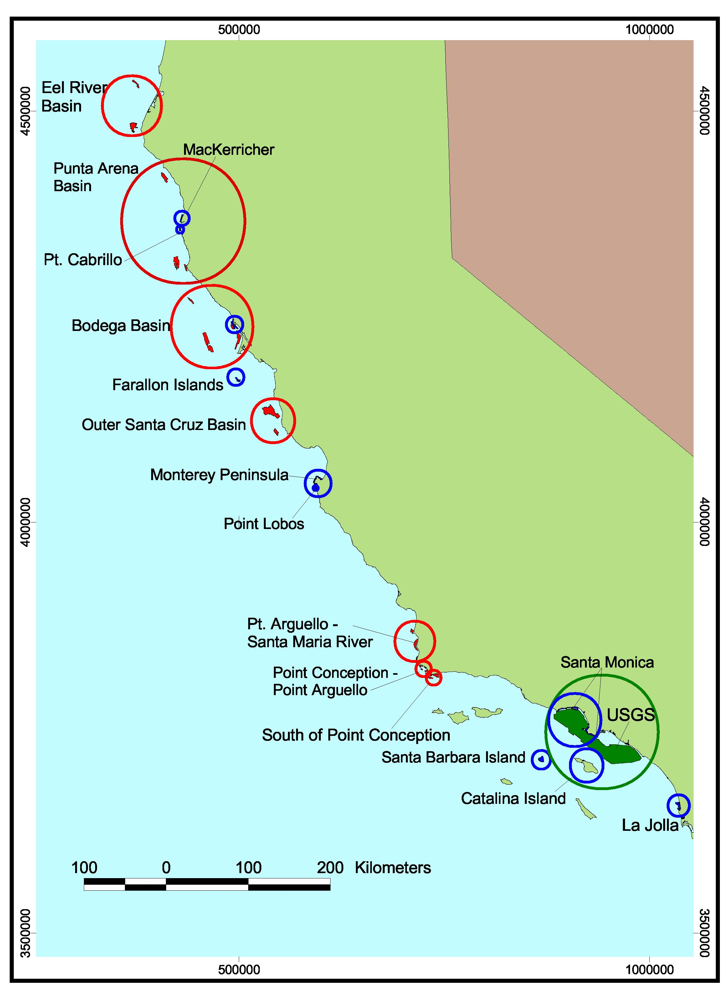
Overview of survey regions. Areas are color-coded by data type (red = sidescan data, blue = CSUMB multibeam data, green = USGS multibeam data).

